***Chemistry***

**18: Representative Metals, Metalloids, and Nonmetals**

**18.10: Occurrence, Preparation, and Properties of Sulfur**

91. Give the hybridization and oxidation state for sulfur in SO2, in SO3, and in H2SO4.

Solution

SO2, *sp*2 4+; SO3, *sp*2, 6+; H2SO4, *sp*3, 6+;

Draw the Lewis structures to determine the hybridization:

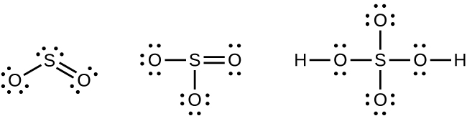

93. Determine the oxidation state of sulfur in SF6, SO2F2, and KHS.

Solution

SF6: S = 6+; SO2F2: S = 6+; KHS: S = 2–

95. Oxygen forms double bonds in O2, but sulfur forms single bonds in S8. Why?

Solution

Sulfur is able to form double bonds only at high temperatures (substantially endothermic conditions), which is not the case for oxygen.

97. Write two balanced chemical equations in which sulfuric acid acts an oxidizing agent.

Solution

There are many possible answers including:

;



99. How many grams of Epsom salts (MgSO4•7H2O) will form from 5.0 kg of magnesium?

Solution

The formula mass for MgSO4·7H2O is 246.4756 g/mol.



This resource file is copyright 2015, Rice University. All Rights Reserved.